**7PAM2000 APPLIED DATA SCIENCE 1**

ASSIGNMENT 2 STATISTICS AND TRENDS

NAME: KAMALI BAKTHAVATCHALAM

STUDENT ID: 22081557

Ten important Asian nations are the subject of this report. The investigation looked at the relationships between several important climate change-related parameters and looked into the underlying reasons of them. For example: percentage of the population living in cities; percentage of arable land; percentage of forest area; percentage of agricultural land; total greenhouse gas emissions (kt of CO2 equivalent); percentage of people having access to electricity; percentage of the total electricity output; percentage of the total electricity consumption; percentage of people using electricity (kWh per capita); annual percentage of population growth; and percentage of GDP devoted to agriculture, forestry etcs.

GITHUB LINK: <https://github.com/kamalibakthavatchalam/statistics-ADS1-ASS2-kamali>

**ANALYSING CLIMATE CHANGE**

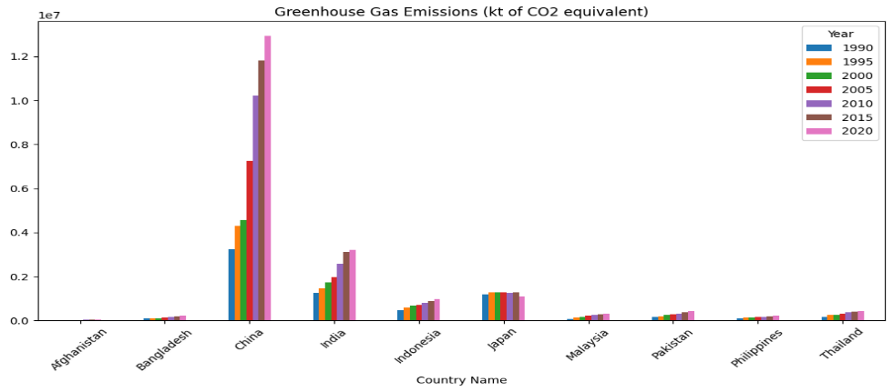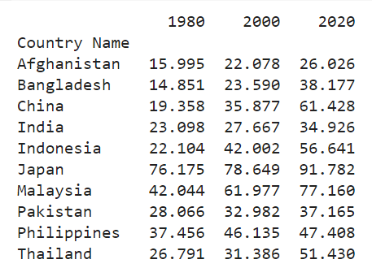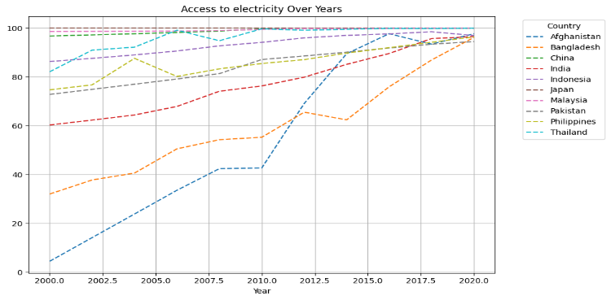

After 2010, Afghanistan, India, and Bangladesh had notable increases in the percentage of people who had access to electricity, which may have contributed to an acceleration of urbanisation. On the other hand, Indonesia's fell after 2017, maybe as a result of fewer people having access to basic services.

China is the country with the greatest emissions, as seen by the bar graph that shows greenhouse gas emissions across nations from 1990 to 2020.

Japan is the third-largest emitter, behind India, which comes in second.

It is Afghanistan that emits the least.

Rapid urbanisation is indicated by the increase in urban populations during the past 40 years, particularly in China, Indonesia, and Thailand. Rising energy use is correlated with urban expansion, which raises CO2 emissions.

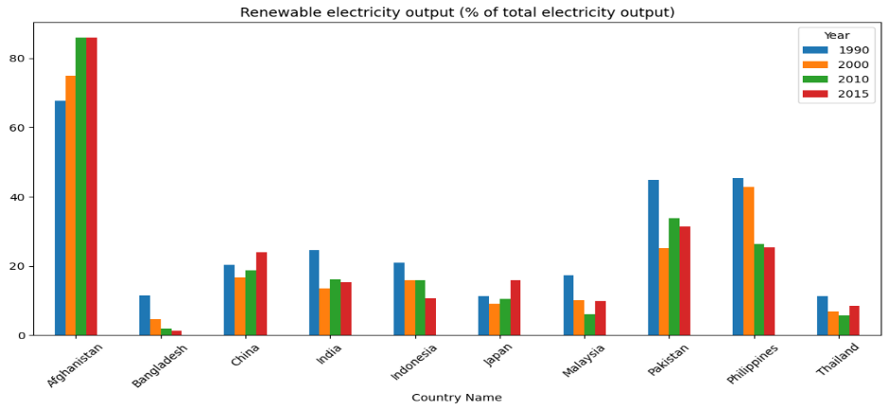

According to the graph, Afghanistan has the greatest percentage of renewable electricity, followed by Pakistan and the Philippines. With far smaller percentages, China and India are more dependent on non-renewable energy sources, which may raise CO2 emissions as a result of their growing use of fossil fuels to generate electricity.

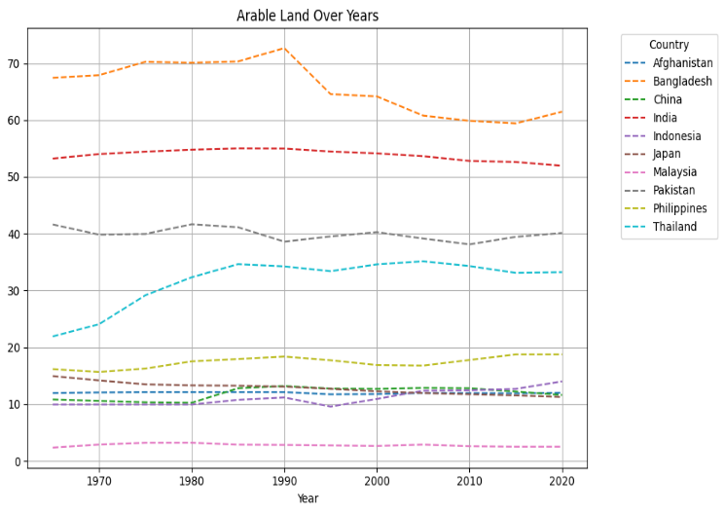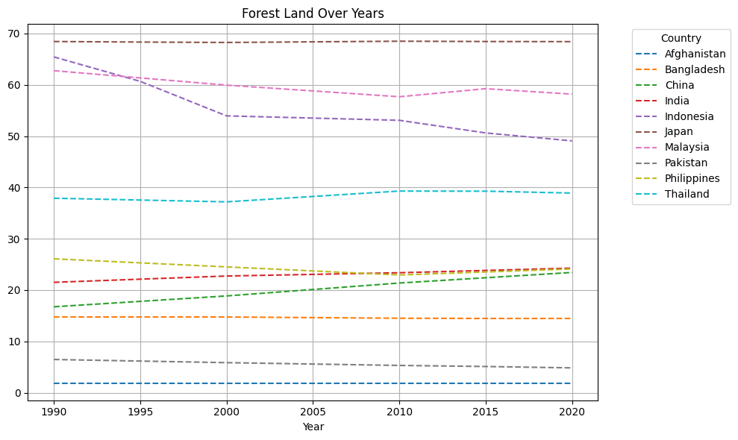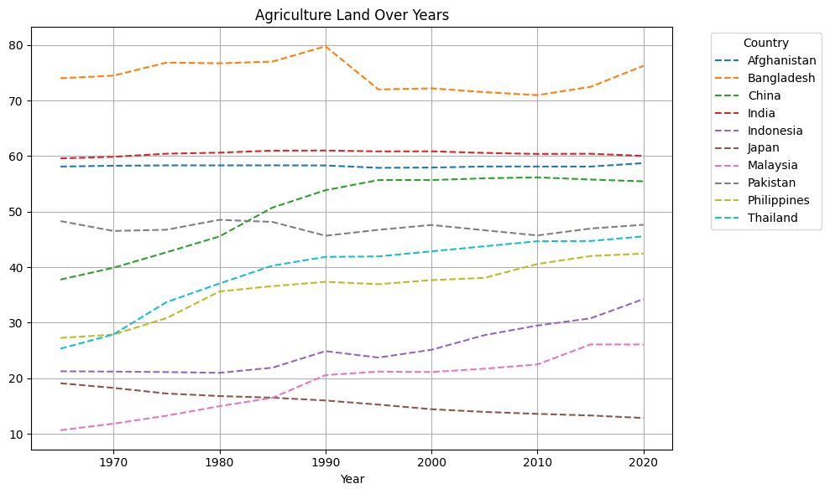

The urbanisation of India and Bangladesh results in a decrease of arable land. Throughout time, Thailand's percentage of arable land has increased. The analysis of forest land plots shows that Indonesia's forest land is decreasing (foreign land loss is caused by the increase of palm oil), while Japan has 70% of the land, which also reduces CO2 emissions. In contrast to Japan, where there is a shortage of farmland and a rise in urbanisation, China's agricultural land (%) has increased by about 20%.

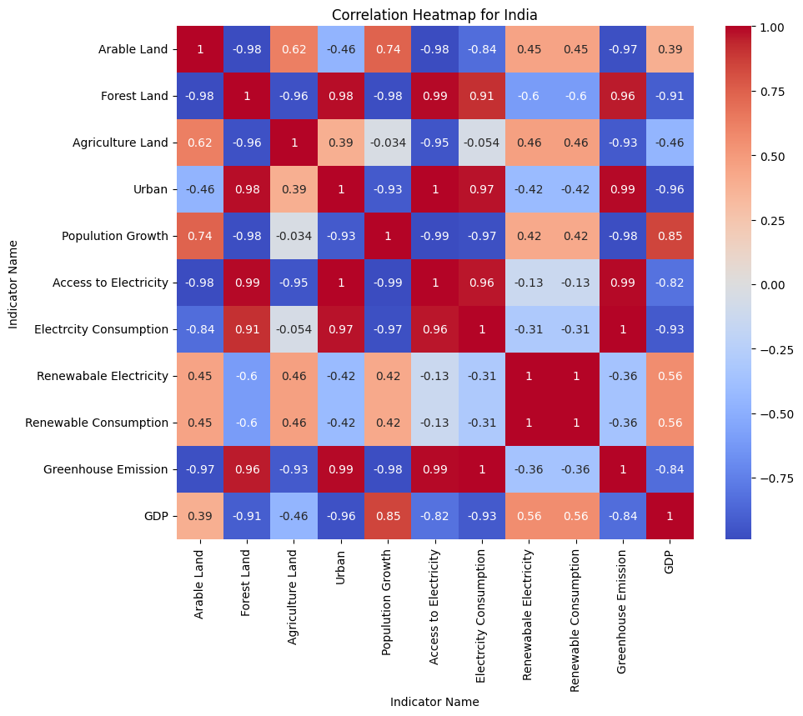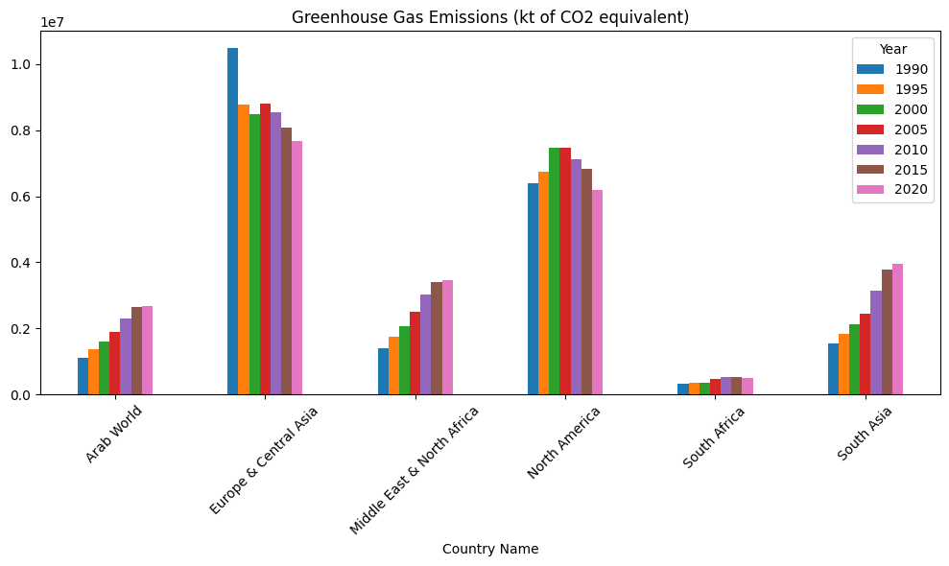

India's heatmap demonstrates the strong relationship between the country's urban population, access to power, energy use, and greenhouse gas emissions. There is a clear negative link between greenhouse gas emissions and arable land. Greenhouse gas emissions increase with the amount of arable land. Reduced access to energy is a result of population expansion over time. CO2 emissions are increased by electricity consumption.

With respect to the climate, the bar graph makes it abundantly evident that North America trails Europe and Central Asia in terms of greenhouse gas emissions. Yet as time goes on, these areas make an effort to use renewable energy sources to cut down on emissions. South Africa emits fewer. Over time, the amount of greenhouse gases released from other locations grows. It is necessary for these areas to take appropriate action to regulate the elements that harm our ecosystem